[VirtualBox](https://www.virtualbox.org/), from Oracle, is an incredibly powerful tool that lets you create virtual machines on a Windows, Mac, Linux or Solaris PC (as long as the machine uses an Intel or AMD chip).

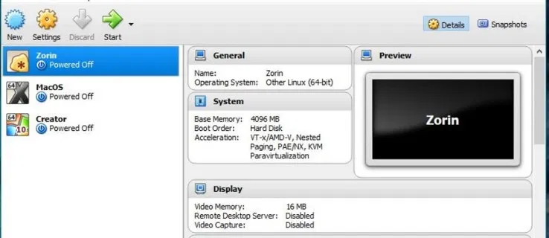

VirtualBox is an outstanding application but, if you’re a Windows user looking for alternatives to VirtualBox, you may like this article on [The 5 best alternatives to VirtualBox](https://www.techjunkie.com/best-virtualbox-alternatives/)

## **Use OVA files with VirtualBox**

To use OVA files with VirtualBox, you need to import them and let VirtualBox configure the file as it needs to. The process is quite straightforward.

1. [Download and install VirtualBox](https://www.virtualbox.org/wiki/Downloads) if you don’t have it already.
2. Open VirtualBox
3. Select File and Import Appliance
4. Select your OVA file (after downloading it on your computer) in the import box and verify the settings in the center window (we don’t need network adaptor or USB so it is recommended to disable them before running up the machine to avoid errors)
5. Make any changes if you need to in that center window
6. Click Import at the bottom.
7. Allow VirtualBox to import the file and configure it for use

It may take a little while to import OVA files.

When you select the OVA file to import, the main details of the VM appear in the center of the import box. You can change some details but not others. If you don’t change them here, you can modify some of them later in the main Settings menu within VirtualBox.

It is worth checking these settings as the machine that created the OVA file may have had fewer resources than the machine you’re importing to. It makes sense to allow the imported VM to have access to the maximum amount of resources so it can run faster.

## **Errors and issues**

OVA files are supposed to be universal but as usual, things aren’t as simple as that. Occasionally when you import an OVA file you will see errors. The syntax can vary but the error message will often say something like ‘Import failed because the image did not pass OVA or OVF conformance or virtual hardware compliance checks.’ If you see these errors, hit retry and the file will usually be imported as expected.

If you got any errors related to the network adaptor or USB ports, please disable them.